**Question 1:**

**Steps: -**

1. ● Create payload for windows.

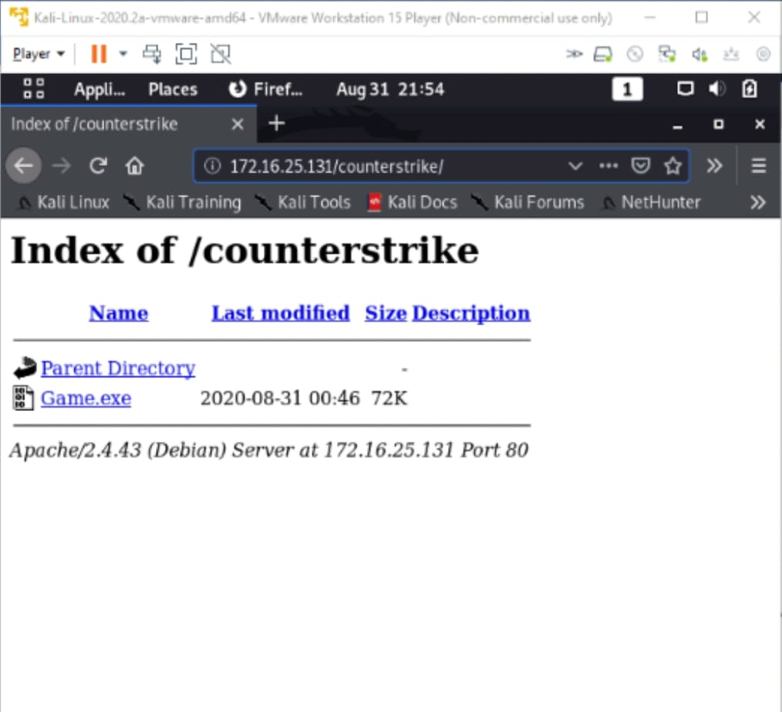

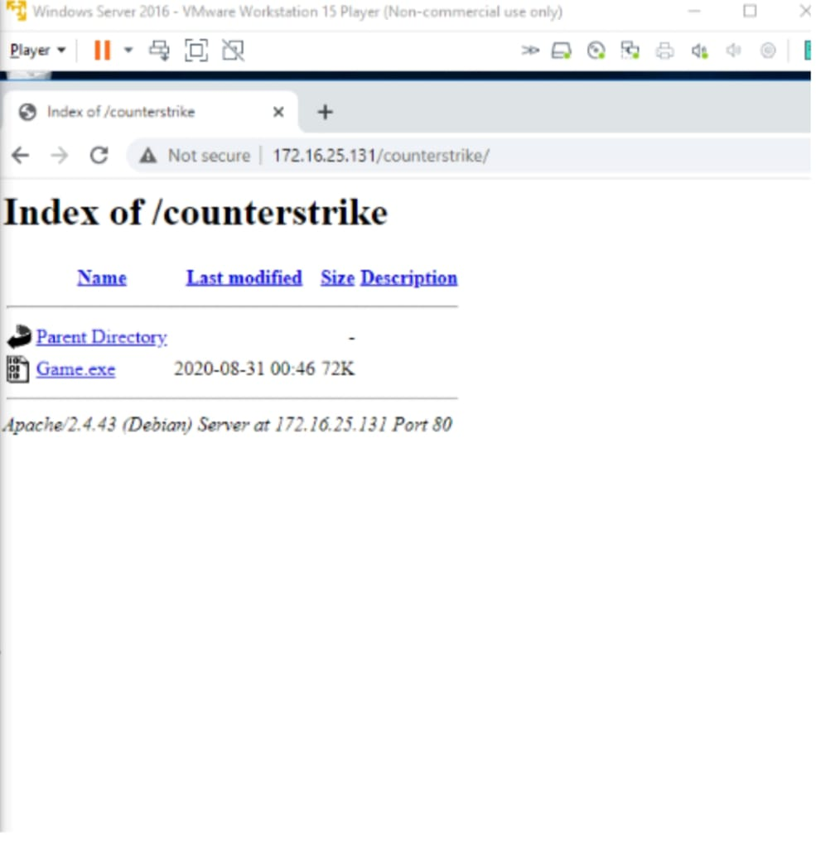

1. Transfer the payload to the victim’s machine

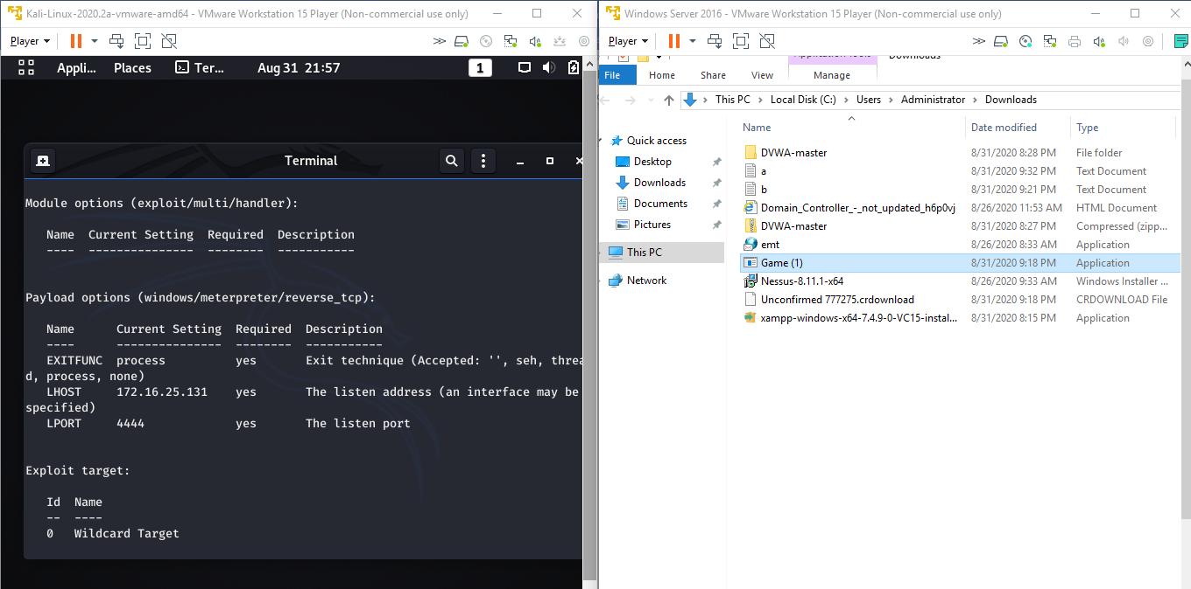

1. Exploit the victim’s machine

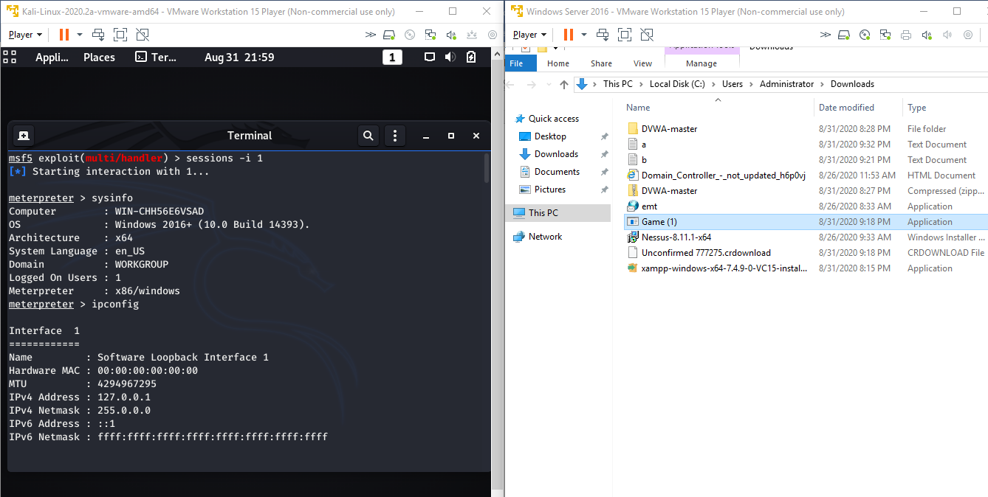

1. Upload/Download a.txt and b.txt in victim machine successfullly

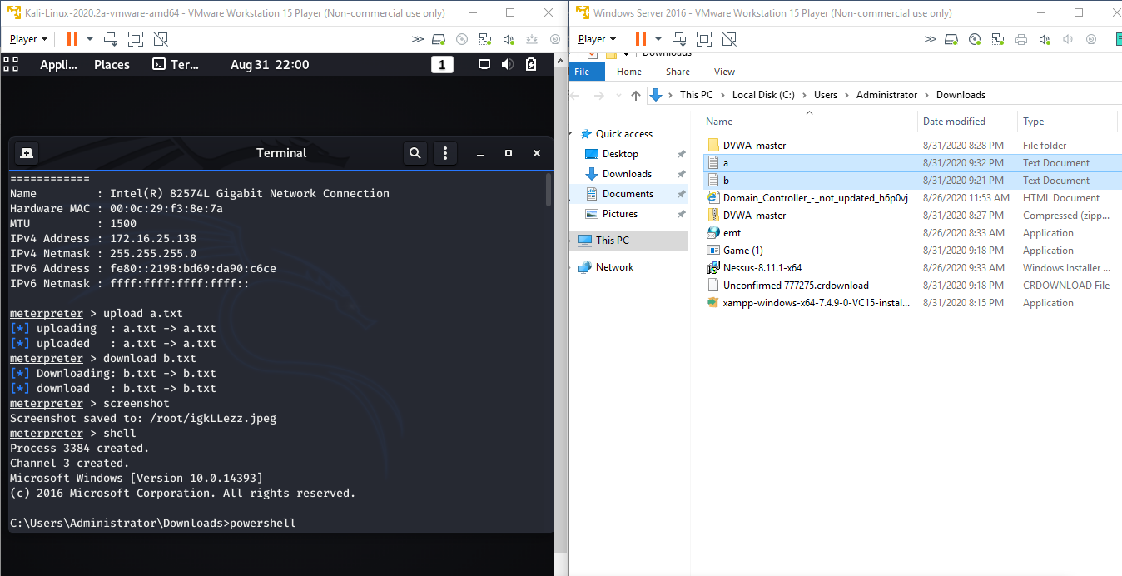

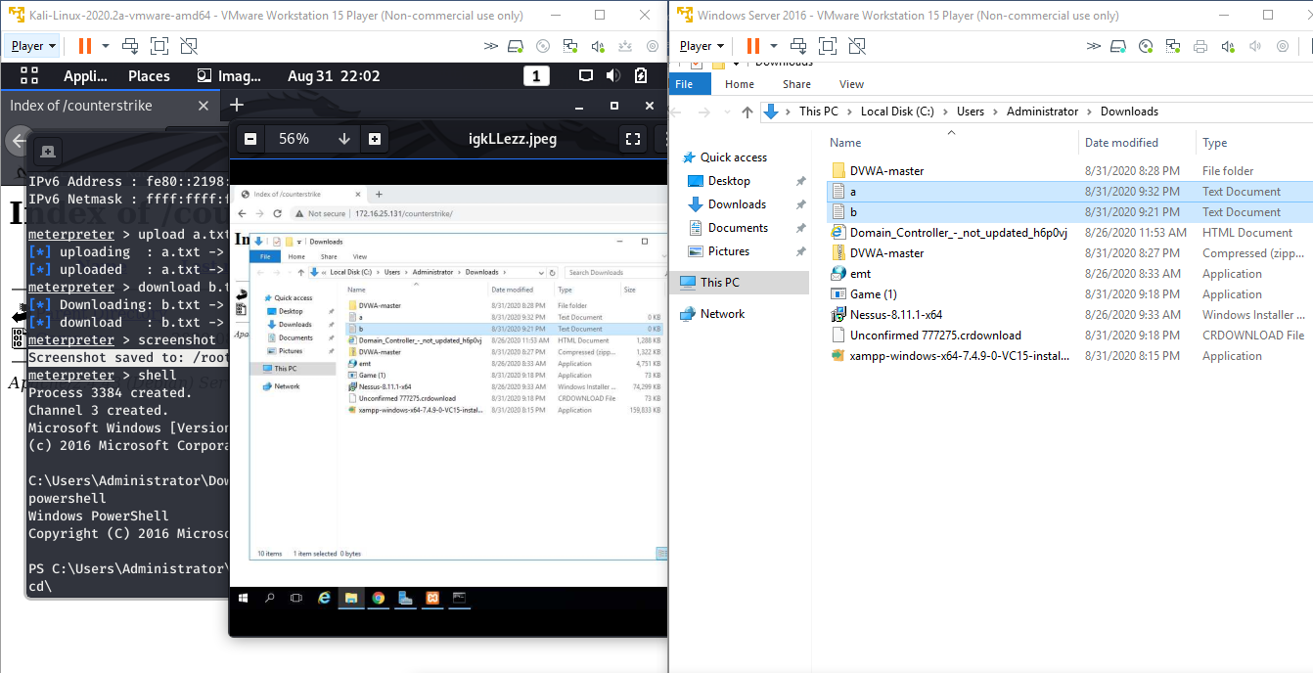

**Question 2:**

1. **● Create an FTP server**
2. **● Access FTP server from windows command prompt**
3. **● Do an mitm and username and password of FTP transaction using wireshark and dsniff.**

**Steps : -**

**Create an FTP server and Access from windows command prompt**

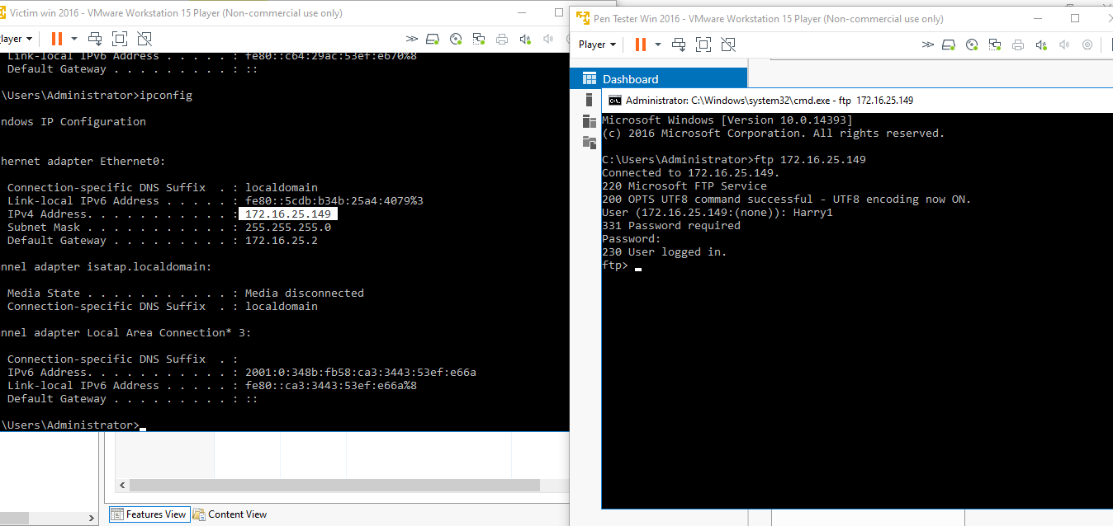

**Do an mitm and username and password of FTP transcation wireshark and dsniff.**

**Using dsniff Username and Password of FTP transaction below**

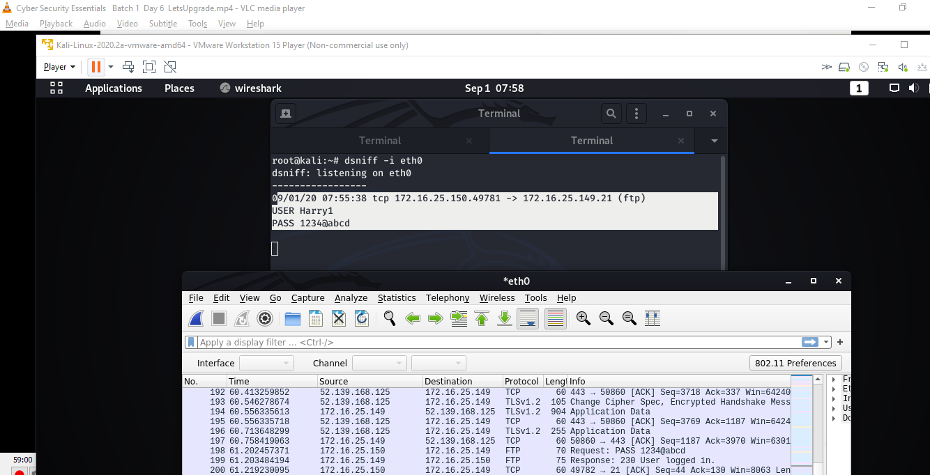

Using wireshark Username and Password of FTP transaction below

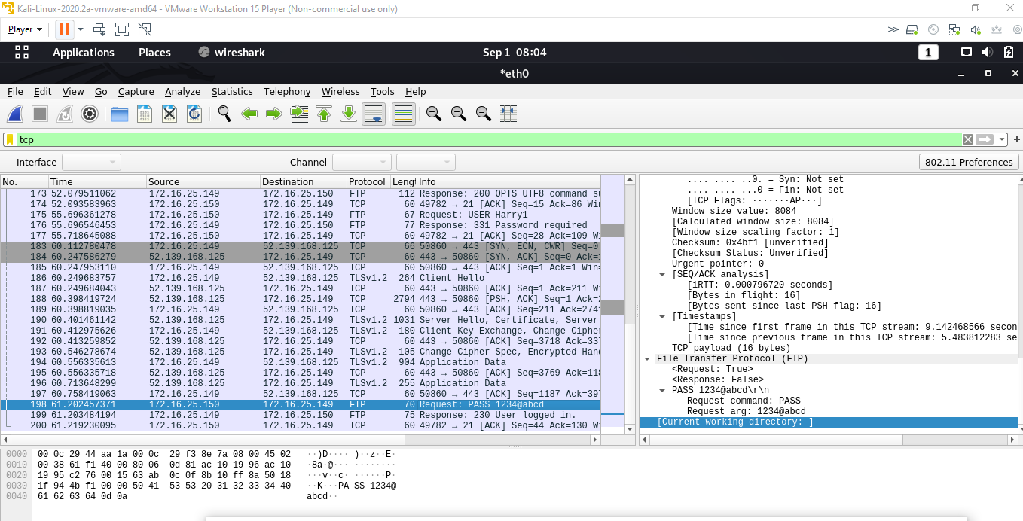

**Using wireshark Username = “ Harry ” and Password = “ 1234@abcd ” of FTP transaction**